Science Report

XX
X University
Course code
Professor's Name
Date

Science Report
Sea and Land Breeze
As the warm air rises and cool air sinks, it creates low- and high-pressure zones, respectively. Air moves fast and apart as air molecules heat up. This is due to a pressure difference between the high- and low-pressure zones causing the wind to move faster. Air expands while heated and contracts on cooling. There exists more space between the molecules, the air is less dense than the surrounding matter, and the hot air floats upward. As the land heats, it warms faster than the sea. Land pressure is relatively lower than that of the sea. The air currents move towards the land, cold air from the sea rises to occupy the less dense air warm air overland. This scenario represents the sea breeze (Park & Chae, 2018).
The airflow pattern changes as the sea heats and the land cools. The difference occurs when the land cools more than the sea. The land's pressure is relatively higher than that of the sea, air currents from the land towards the sea. As a result, warm air from the sea rises. This scenario represents the land breeze—the air pattern flow changes due to heat from the lamp (Park & Chae, 2018).
The airflow pattern changes when the wind blows from a concentrated pressure over the water to a less concentrated pressure over the land resulting in a sea breeze. In contrast, in Land Breeze, there is a reduced temperature gradient between the sea and the land at night, causing the wind to blow from land to sea.
As I learned in class, Sea and Land Breeze refers to wind movement as it changes its direction daily in areas around the coast. During the day, air blows from the sea to the land. At night, air blows from the land towards the sea. Sea and Land Breeze are caused by the difference in air pressure, leading to the land heating faster and cooling faster than the ocean. Sea breeze: During the daytime, the land heats more than the sea. As a result, the land's pressure is relatively lower than that of the sea. The air from the sea is blowing to the land. Land breeze: At night, the land cools more than the sea. The land pressure is relatively higher than the sea, and the wind blows from the land to the sea.
Coriolis Effect
The black dot moves in a clockwise direction after pressing start, then stops after pressing reset after that counter-clockwise after moving the red's initial position and direction. There is an apparent deflection of the winds to the right in the northern hemisphere (The Coriolis Effect - Currents: NOAA’s National Ocean Service Education, n.d. 2021).
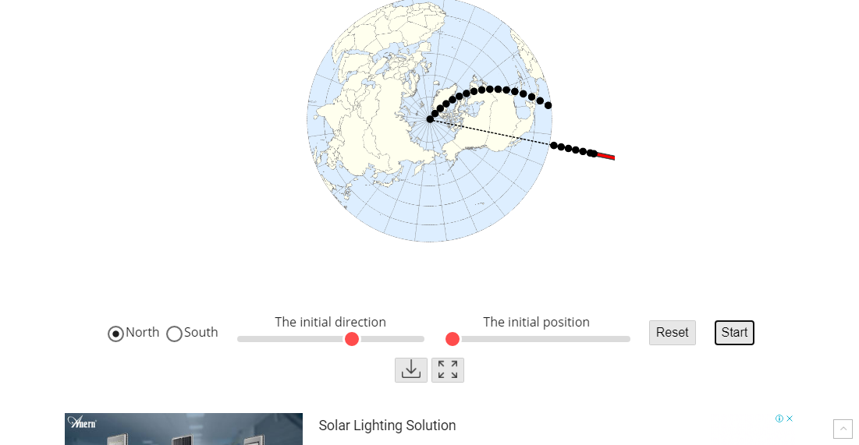
The above is a screenshot as you play around with the starting conditions until you can get the black dot to cross over New York.

Air Currents in The Atmosphere
The air currents are moving towards the equator compared to learned knowledge which states that it is wind divergence of westerlies and northeast trade winds, which forms subtropical jet streams.
The wind patterns seem to collide; (these will look like a light blue line running east to west across the green patterns in the ocean areas). The lines correspond to the polar jet streams, which occur due to the convergence of winds.
The pattern changes direction at the height of 700hPa. These are at the top of the troposphere. At the troposphere, the tops of two of the cells are shown in the "Global Atmospheric Circulation" picture. Weather forecasters describe this air movement as a Jet Stream and compare it to a river of air flowing 35,000 feet above your head. This air wobbles north and south from day to day and month to month as the cells adjust to temperatures. It has a significant impact on our daily weather.
When the globe moves around, it leads to the formation of narrow streams of currents at 10Hpa. The movement matches the description of a "river of air."
Hurricanes
Hurricanes form when warm moist air over water starts to rise (My NASA Data, n.d. 2021). The rising air up is replaced by existing cooler air over the sea. The process leads to the formation of clouds and thunderstorms. As the thunderstorms grow, they begin to rotate. While typhoon forms when winds blow into areas of the ocean where the water is warm. These winds collect moisture and rise as it moves, while colder air moves below, which creates pressure, which causes the winds to move very quickly. The winds rotate, or spin, around a center called an eye.
Areas with orange colors produce more hurricanes. The orange color represents the longer wavelength of the ocean. The fall season produces more hurricanes because hurricanes are fueled by heat, and the sea surface temperature in this season is 88F degrees and above.
When a hurricane passes over land, it losses wind speed, and the category number drops down. For instance, when it crosses Puerto Rica and Cuba forms a landfall in Florida in the mainland USA. Varying the "H" and "L" positions results in landfall emergence near New York. The Northward movement of the earth causes the north and west movements of the hurricanes and the subtropical ridge's high pressure.

References
My NASA Data. (n.d.). NASA. Retrieved April 7, 2021, from https://mynasadata.larc.nasa.gov/basic-page/hurricane-dynamics
Park, M. S., & Chae, J. H. (2018). Features of sea–land-breeze circulation over the Seoul Metropolitan Area. Geoscience Letters, 5(1), 1–12. https://doi.org/10.1186/s40562-018-0127-6
The Coriolis Effect - Currents: NOAA’s National Ocean Service Education. (n.d.). National Ocean Service. Retrieved 2021, from https://oceanservice.noaa.gov/education/tutorial_currents/04currents1.html

